ADINA ISRAN
2303A52222
BATCH - 42

API Integration: Connecting to External Services with Error Handling

Task 1 – Movie Database API Integration
Scenario
You are building a movie recommendation tool that fetches movie details
from a public Movie Database API.
Task
Use AI to generate a Python script that connects to a Movie API and
retrieves movie information by title.
Instructions
• Use requests library to fetch movie details.
• Accept movie title as user input.
• Display:
o Title
o Release year
o Rating
o Plot summary
• Implement error handling for:
o Invalid movie name
o API key errors
o Network timeout
o Empty API response
Expected Output
• A working Python script that fetches movie details.
• Graceful error messages instead of crashes.
• Clean, readable output format.
Prompt:
"Using the requests library, write a Python script that asks for a movie title and fetches details from an API Include a robust try-except block to handle Timeout and JSONDecodeError, and ensure it prints a friendly message if the movie isn't found instead of crashing."

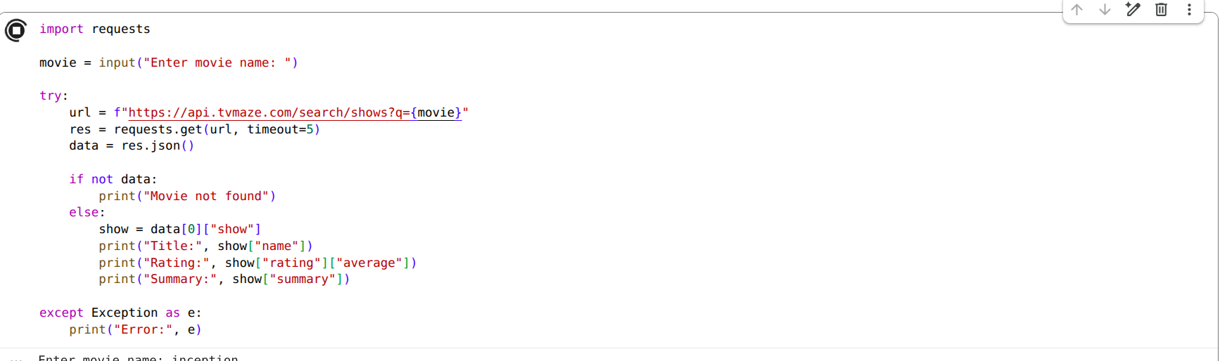

Justification:
This prompt uses AI to build a "defensive" wrapper around an external service. It’s not just about getting the data; it's about teaching the AI to anticipate that the internet is unreliable and that users often make typos.

Task 2 – Public Transport Schedule API
Scenario
A city transport app needs to fetch bus/train arrival timings from a
transport API.
Task
Use AI assistance to integrate a transport schedule API.
Instructions
• Fetch arrival times for a given station/stop ID.
• Validate user input.
• Handle errors such as:
o Invalid stop ID
o Server unavailable
o Timeout errors
• Display next 3 arrival times in formatted output.
• Implement retry logic (minimum 1 retry attempt).
Expected Output
• Python script showing upcoming arrivals.
• Retry mechanism working properly.
• Proper exception handling using try-except blocks.
Prompt:
"Create a script to fetch bus arrival times for a specific Stop ID. Use AI to implement a 'retry' decorator or a loop that attempts the request again if the first one fails, and ensure the output only displays the next three upcoming arrivals."

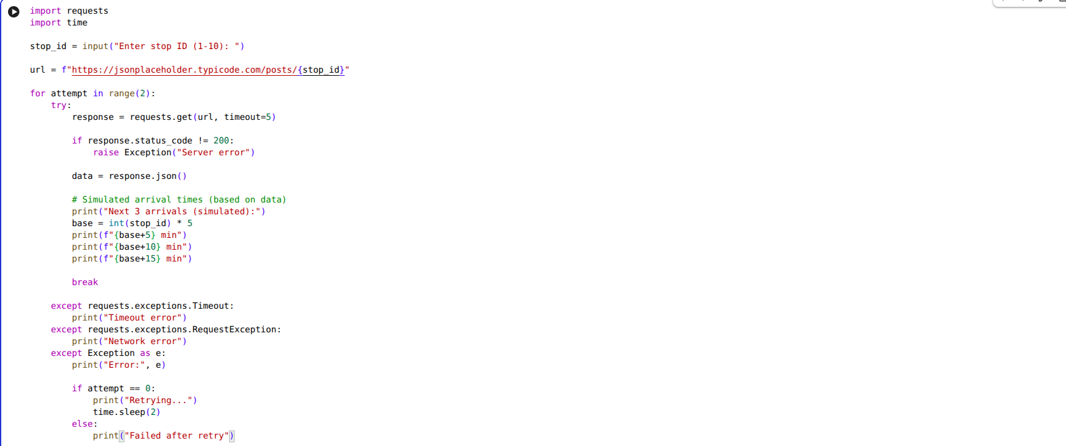
Justification:
Transport APIs often flicker or time out. By asking the AI for "retry logic," we are simulating real-world engineering where we don't just give up on the first failure, making the app feel more professional and reliable.

Task 3 – Stock Market Data API
Scenario
You are developing a finance dashboard that retrieves live stock prices.
Task
Use AI to generate a Python script that fetches stock data from a
financial API.
Instructions
• Accept stock symbol as input.
• Retrieve:
o Current price
o Day high
o Day low
• Handle:
o Invalid stock symbol
o API rate limits
o Missing fields in JSON response
• Validate and safely parse JSON response.
Expected Output
• Script fetches and displays stock information.
• No unhandled exceptions.
• Clear error messages for invalid symbols or rate limits.

Prompt:
"Generate a script to fetch stock prices by symbol. Ask the AI to include specific logic for 'Rate Limiting' HTTP 429 errors and a safety check to see if the 'price' key actually exists in the JSON response before trying to print it."
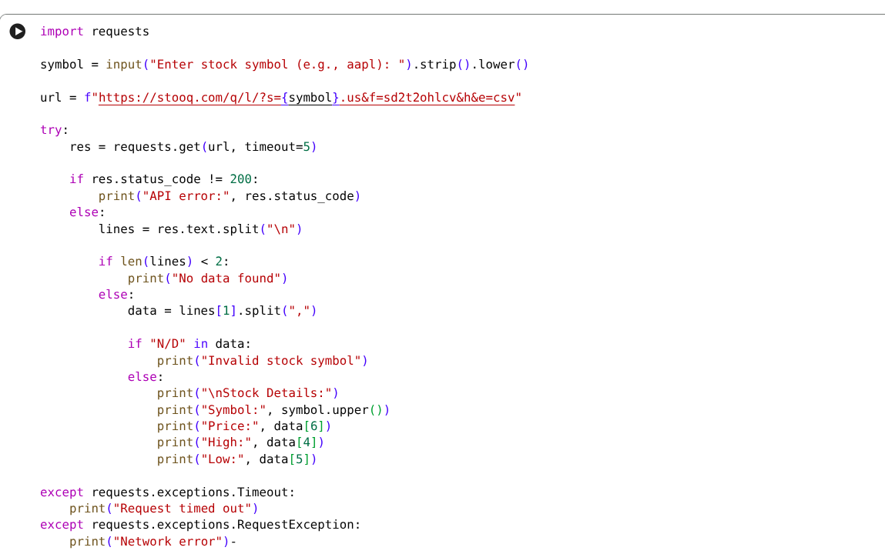
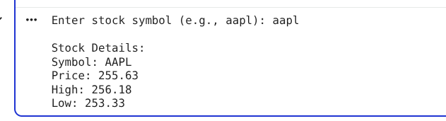
Justification:
Financial APIs are notoriously strict with limits. This approach uses AI to handle the "business rules" of an API, preventing the script from being banned for too many requests and avoiding "KeyError" crashes when data is missing.

Task 4 – Geolocation API (IP AddressLookup)
Scenario
A cybersecurity tool needs to detect the geographical location of a user
based on IP address.
Task
Integrate a Geolocation API using AI assistance.
Instructions
• Accept IP address as input.
• Fetch:
o Country
o City
o ISP
• Validate IP format before making API call.
• Handle:
o Invalid IP format
o API failure
o JSON decoding errors
Expected Output
• A script that returns geolocation details.
• Input validation implemented.
• Robust error handling included.

Prompt:
"Write a Python tool that takes an IP address and returns the country and ISP. Before calling the API, use a Regular Expression (Regex) to validate that the input follows a proper IP format to save unnecessary API calls."
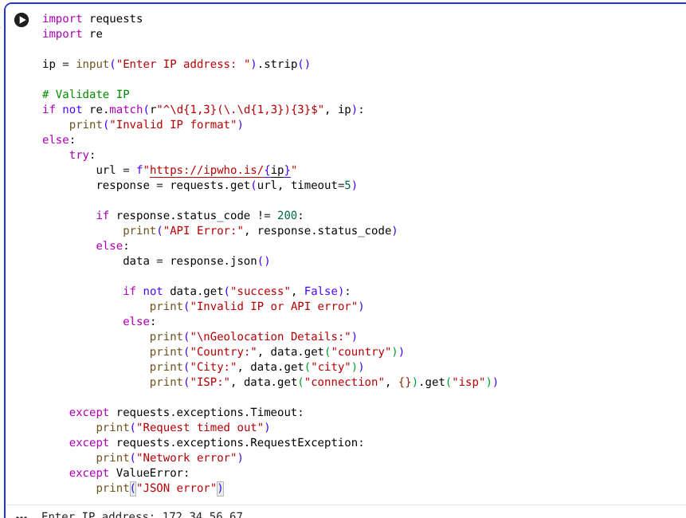
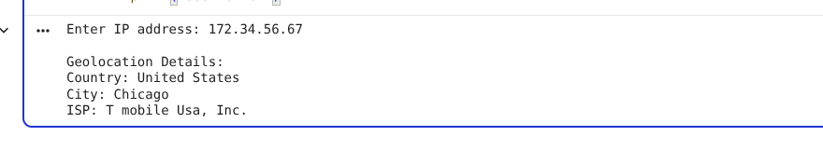
Justification:
This highlights "client-side validation." I’m using AI to write complex validation (Regex) so we don't waste API quota or bandwidth on data we already know is invalid before it even leaves our computer.

Task 5 – Real-Time Application: Payment Gateway Simulation API
Scenario
You are building a test payment integration system that connects to a
sandbox payment API.
Task
Use AI to generate a Python script that simulates payment processing.
Instructions
• Send POST request with:
o Amount
o Currency
o Payment method
• Validate input values.
• Handle:
o Invalid payment details
o HTTP status errors (400, 401, 500)
o Network interruptions
• Display transaction status clearly.
• Log failed transactions to a file.
Expected Output
• Script processes simulated payment.
• Errors handled gracefully.
• Failed requests logged properly.

Prompt:
"Simulate a POST request to a payment sandbox. Ask the AI to log any failed transactions into a local errors.log file, while displaying a clear 'Success' or 'Declined' message to the user based on the HTTP status code."

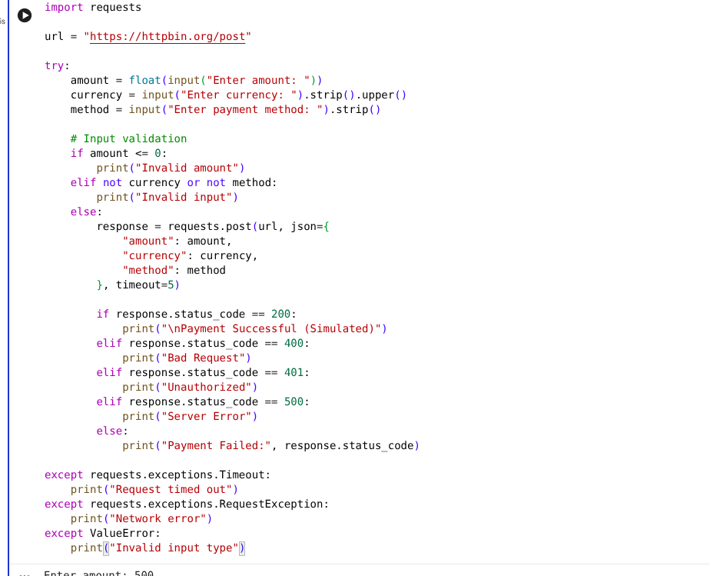
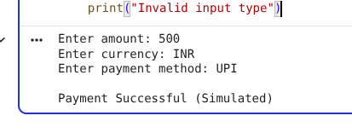
Justification:
Payment systems require an audit trail. This prompt shows how AI can help implement "logging," which is a critical professional skill—ensuring that even when things go wrong, we have a record of exactly why it happened for troubleshooting.

